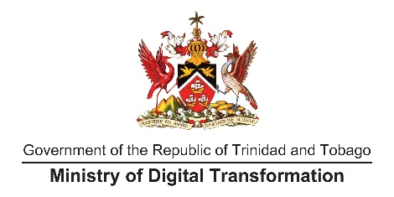

**MEDIA RELEASE**

*For Immediate Release*

Thursday 24 November, 2022

**A Digital Future for Belle Vue**

“This Centre is not a young people thing, it is there for everyone”. Minister of Digital Transformation, Senator the Honourable Hassel Bacchus, speaking at the official opening ceremony of the thirteenth ICT Access Centre, located inside the Belle Vue/Dibe/Dundonald Hill Community Centre, said to all in attendance to “make use of the Centre, it is there for you!”.

The Community Centre was opened by the Minister of Sport and Community Development, the Honourable Shamfa Cudjoe, and Minister of Finance and MP for Diego Martin North East, the Honourable Colm Imbert, on Wednesday November 23,2022.

At the opening, which is part of the ongoing partnership between the Ministries of Sport and Community Development and Digital Transformation, Minister Bacchus urged community members to visit the centre. “You have a critical role - come and use the centre, protect and care for it, and we (the Government of Trinidad and Tobago) will continue to provide you with what you need.” The ICT Access Centre, which is the largest one thus far, is outfitted with thirteen desktop computers, twelve laptops, printing facilities, and a training room with audio-visual technologies.

Even while the Opening Ceremony was in train in the Auditorium of the Centre, it was shown on screens downstairs in the Access Centre, where members of the community, young and old, gathered to watch the live stream. They took the opportunity to ‘Connect and Create’ on the devices in the hub, making use of online programmes to create “Welcome to Belle Vue” posters, and play games. The other facilities of the Access Centre encourage persons to ‘Educate and Innovate’, in a space where various digital literacy programmes can be taught. These programmes are already being rolled out at other Access Centres in underserved or ICT-excluded areas in Trinidad, including the Adult Literacy Tutors Associations (ALTA) Online classes, and YTEPP’s Digital Literacy course for beginners.

The Belle Vue, Dibe, and Dundonald Hill community is home to some 4,000 residents and has produced calypsonians and Olympians like the Mighty Conqueror and Chris Braithwaite who competed in the 1976 and 1980 Summer Olympics.

The robust and active Community Council is already planning to explore digital technology opportunities and endless possibilities at the state-of-the-art ICT Access Centre.

“I was pleasantly surprised when I saw the nice machines with webcams, headsets, and laptops, the machines are user-friendly and I really hope that it’s maximised to its fullest potential,” said Jodette Darby who lives in the community.

MP Imbert who spoke at the official opening assured Minister Bacchus that there will be competition to use the ‘Connect and Create’ facilities and ‘Educate and Innovate’ training rooms and expressed excitement to see Belle Vue transformed into a digital society.

Minister Cudjoe, in delivering the feature address, described the opening of the Community Centre as an auspicious event, expressing gratitude for governmental partnerships that give communities a place to meet, engage and learn.

The Ministry of Digital Transformation has committed to bridging the digital divide across the nation of Trinidad and Tobago with the construction of thirty (30) more ICT Access Centres over the next few months, and the rollout of various digital skills training programmes to ensure that no one is left behind in a digital Trinbago.

###